Capstone Project — Part B Project Log
Student Name(s): Ashraful Islam; Huzaifa Iqbal; Sonu; Dominic Kipchirchir
Student ID(s): 240135; 240220; 250001; 240401
Project Title: SEDAS — Social Engineering Defence and Awareness System (implementation of the Part A design by Ashraful Islam, MIS5203)
Supervisor: Dr Chandana Withana
Week: 2 and 3 (combined submission)
Git Repository URL: https://github.com/ailinkon/MIS5320-SEDAS-CyberProjectB (private; supervisor holds collaborator access)

1. Summary of Work Completed
Weeks 2 and 3 covered the Unified Process Construction phase: benchmark establishment, two further services implemented, the system integrated end to end behind a working interface, and module ownership distributed across the team.

1.1 Benchmark establishment (supervisor priority)
- Source paper identified. Traced our dataset to its source publication and adopted it as the project benchmark: Al-Subaiey, A., Al-Thani, M., Alam, N. A., Antora, K. F., Khandakar, A., & Zaman, S. M. A. U. (2024), 'Novel interpretable and robust web-based AI platform for phishing email detection', Computers and Electrical Engineering, 120, 109625 — numbered [41], continuing the Part A reference register [1]–[40].
- Exact dataset match confirmed. The paper's integrated corpus (42,891 phishing / 39,595 legitimate, ≈82,500 emails) matches our loaded dataset exactly (42,891 / 39,595; 82,486 usable rows after null removal). Same six public sources: Enron, Ling-Spam, CEAS 2008, Nazario, Nigerian Fraud, SpamAssassin. Same merged 'text_combined' field.
- Replication executed. Implemented services/detection/compare_models.py and executed the paper's TF-IDF + SVM pipeline on the identical corpus and split. Result: F1 0.9916 (accuracy 0.9912, precision 0.9913, recall 0.9918, FP rate 0.0095) against the published 0.99 — the replication matches the benchmark, validating our pipeline.
- Documented. A standalone Dataset and Benchmark Justification document was prepared for the supervisor consultation, mapping the evaluation parameters to Part A references [3], [7] and [8] and the dataset to [41], with the execution evidence embedded.

1.2 URL Verification Service (FR-03, FR-04; refinement R-01)
- Analysis layer. Heuristic URL risk analysis: absence of HTTPS, raw IP address, '@' obfuscation, multiple hyphens, excessive subdomain depth, high-risk TLDs, known shorteners, abnormal length, and credential-lure keywords — each returning a plain-English finding with a weighted risk score.
- Tamper-evident registry. SHA-256 hash-chained, append-only SQLite registry: each entry hashes its own content plus the previous entry's hash, so any modification breaks the chain. Endpoints: POST /verify, POST /report, GET /chain/validate, GET /health on port 8002.
- Design rationale. This delivers the tamper-evidence intent of the Part A blockchain layer without Ethereum gas fees, wallet infrastructure or block latency, per refinement R-01. Limitation recorded: the proof of concept provides tamper-evidence, not decentralised consensus.

1.3 Frontend integration (FR-07 groundwork)
- Live demo page. frontend/demo.html — a single-file interface calling both services: verdict badges, risk scores out of 100, explainability/finding chips, registry proof display and latency readout. CORS middleware added to both services (permissive for local demonstration; restriction recorded as a security finding).
- End-to-end integration verified. Browser → detection service (port 8001) and URL service (port 8002) → responses rendered, in single-digit to low-double-digit milliseconds.

1.4 Awareness Training Module scaffold (FR-05, FR-06)
- Database schema. Four tables — users (persona, risk score), lessons (persona, difficulty, body), questions (four options, correct answer, explanation), attempts (append-only history).
- Service endpoints. POST /users, GET /lessons, GET /lessons/{code}/quiz (answers withheld from the client), POST /submit, GET /progress/{username}, GET /health on port 8003.
- Content seeded. Five starter micro-lessons and seven quiz questions seeded, mapped to attack vectors from the Part A review and grounded in the Theory of Planned Behaviour.
- Ownership. The scoring engine (attempt scoring, EWMA risk update, risk banding, adaptive lesson selection) is specified and stubbed for its module owner, with a written technical brief and test specification.

1.5 Team distribution and preparation
- RACI finalised. Module ownership formalised in the project plan RACI across thirteen activities with a single accountable owner each: detection/URL/frontend (Ashraful), training scoring engine (Dominic), awareness content and project records (Sonu), security assessment/testing/user documentation (Huzaifa).
- Individual briefs issued. Each member received a technical brief covering their module's purpose, specification, tests to write, commit workflow and viva questions; a shared 47-question viva preparation document was issued covering the project, the benchmark comparison and each module.
- Repository access. Supervisor added as repository collaborator; branch-based workflow with pull-request review adopted for team contributions.

2. Evidence of Technical Progress

2.1 Benchmark replication
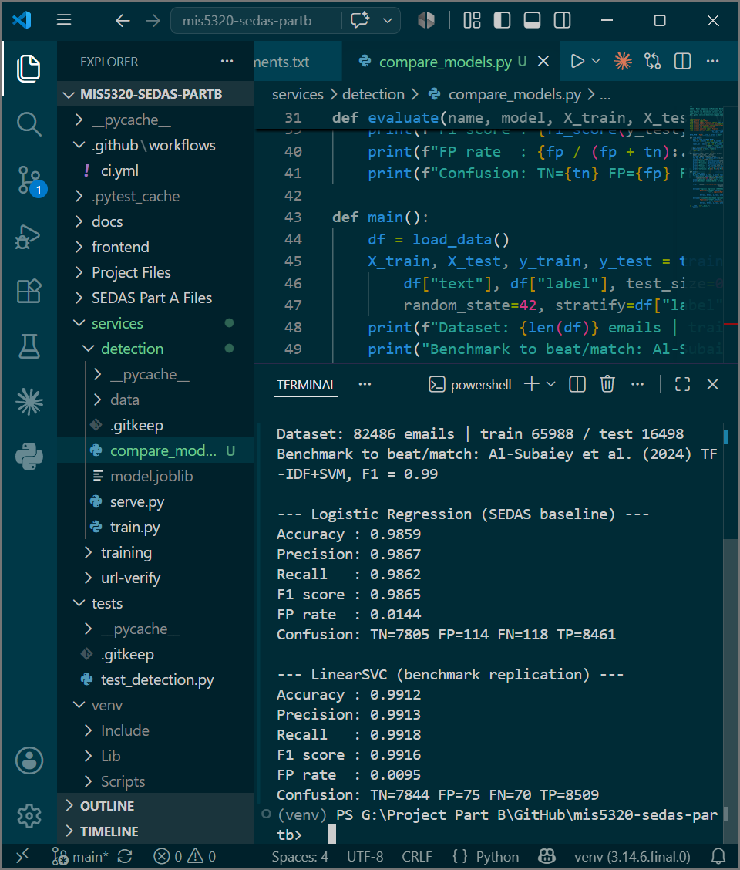
Execution of compare_models.py on the full 82,486-email corpus: Logistic Regression baseline F1 0.9865 (FP 0.0144) and LinearSVC benchmark replication F1 0.9916 (FP 0.0095), against the published [41] result of 0.99 on identical data.

2.2 URL verification service
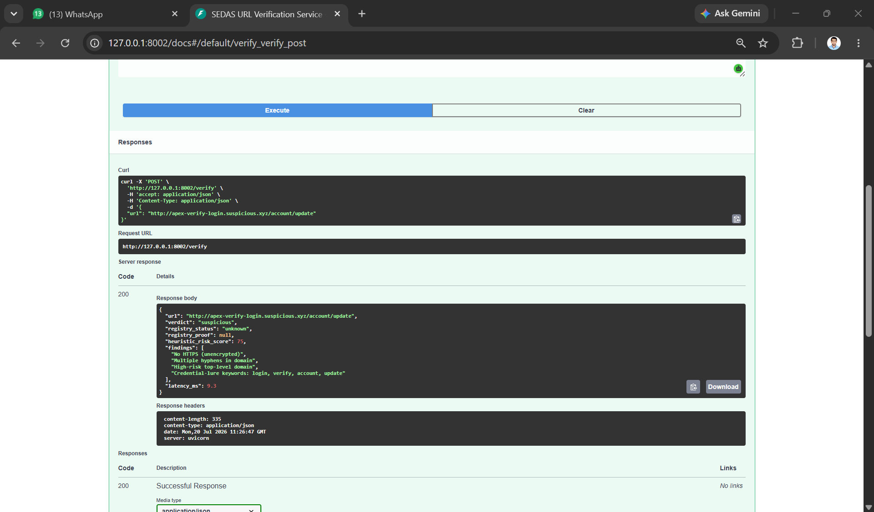
POST /verify on an unreported suspicious URL: verdict 'suspicious', heuristic risk 75/100, four findings returned (no HTTPS, multiple hyphens, high-risk TLD, credential-lure keywords), 9.3 ms.
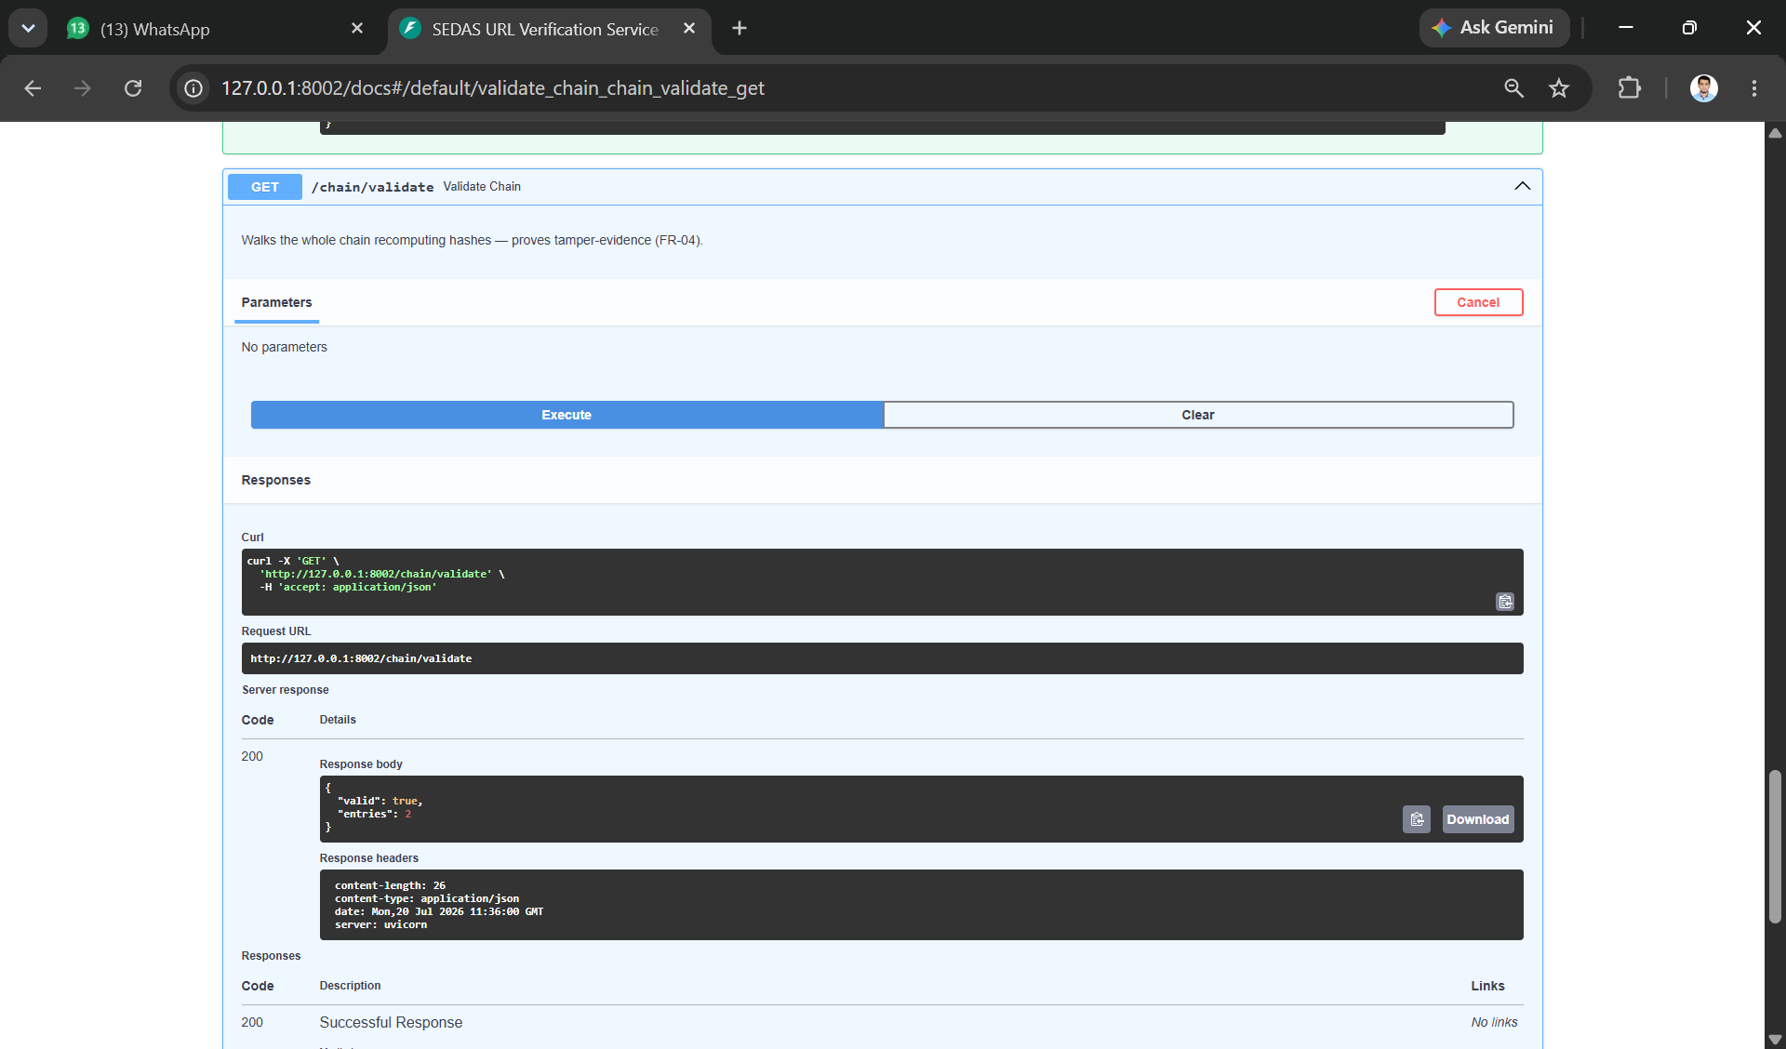
GET /chain/validate recomputes every hash in the registry: valid = true across all entries, demonstrating tamper-evidence (FR-04, refinement R-01).

2.3 Integrated system through the frontend
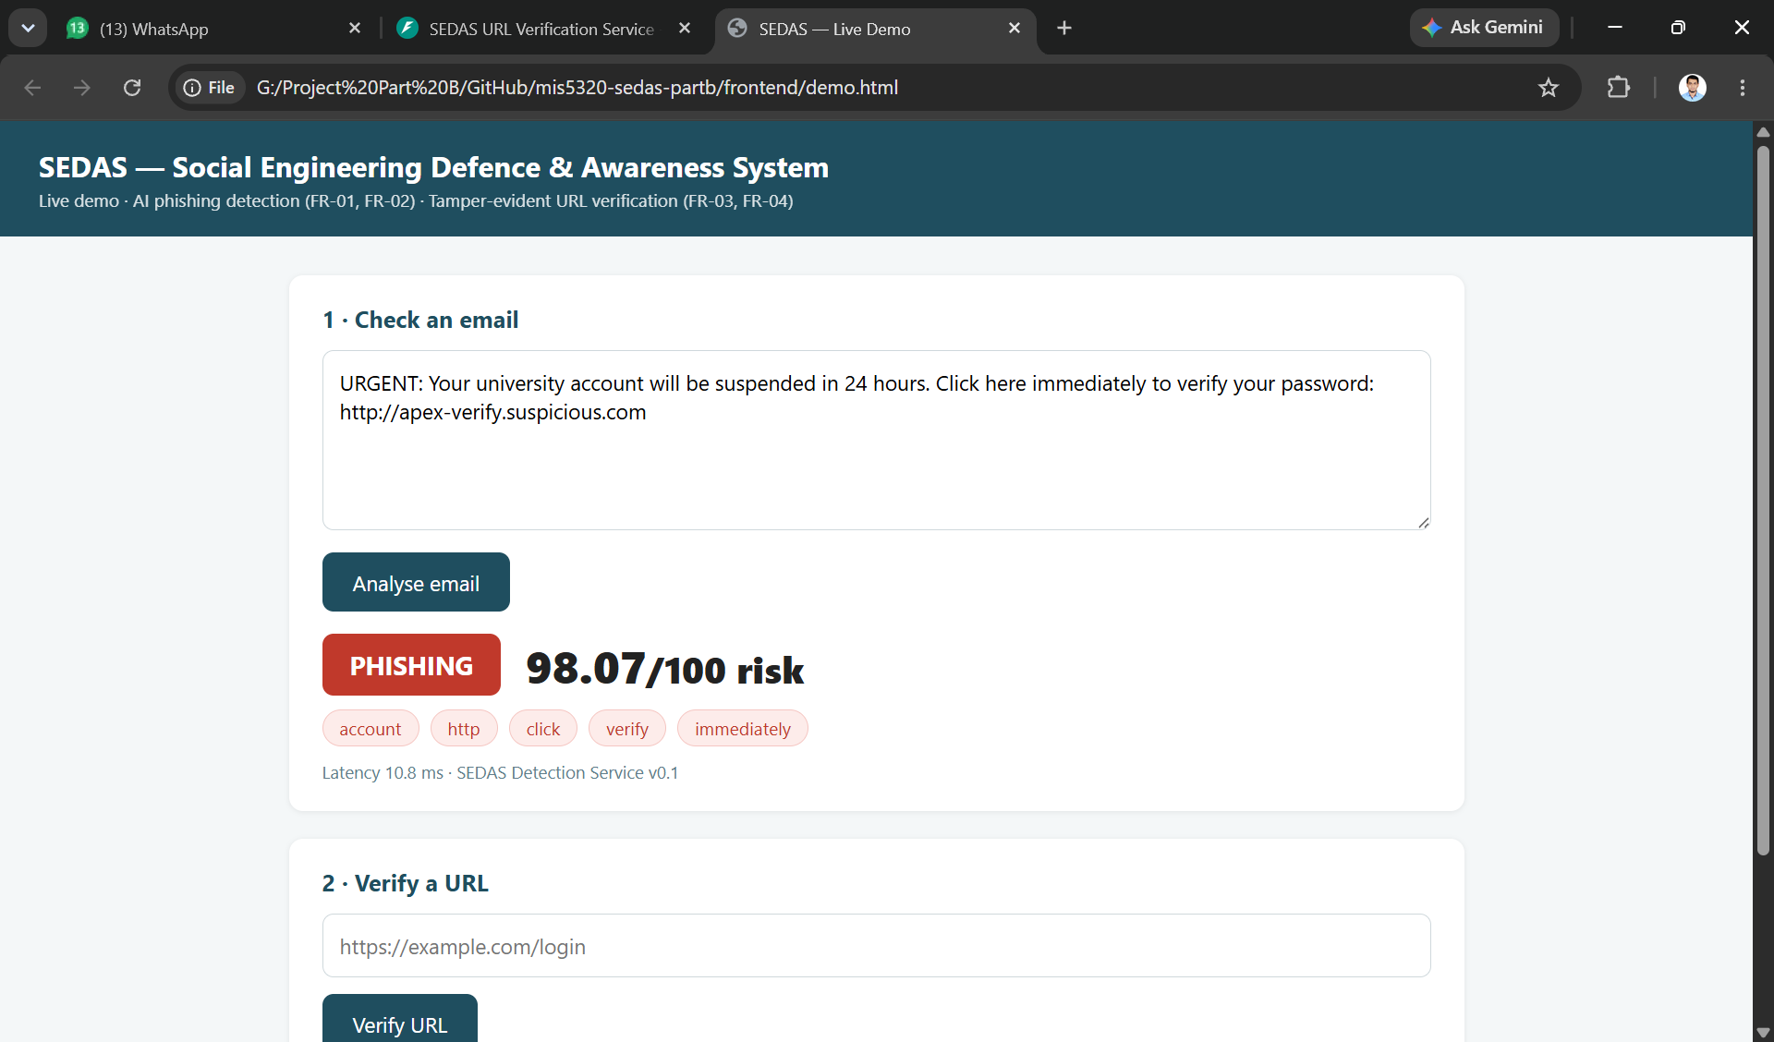
Detection through the interface: simulated phishing email classified PHISHING at 98.07/100 with explainable indicators (account, http, click, verify, immediately), 10.8 ms (FR-01, FR-02).
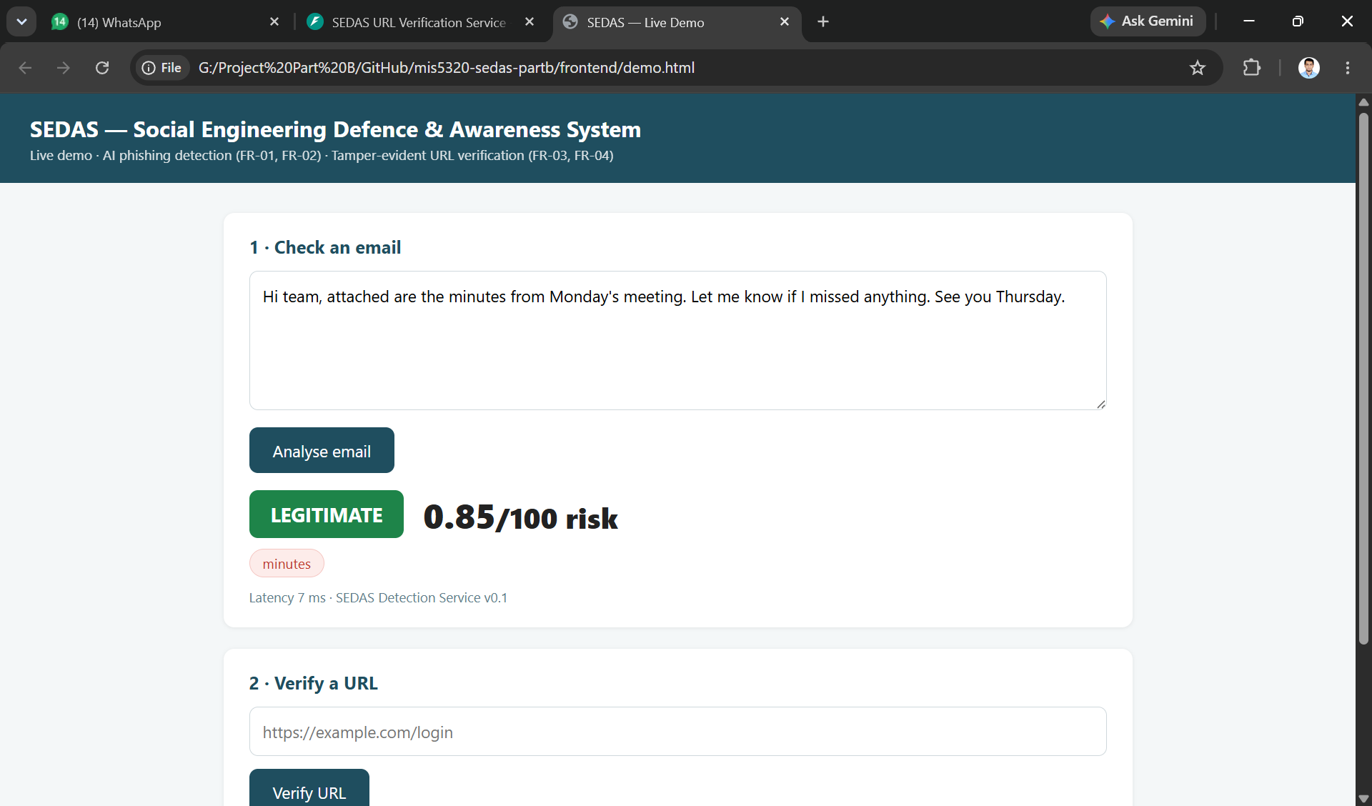
Contrast case: legitimate email classified LEGITIMATE at 0.85/100, 7 ms — consistent with the measured 1.44% false-positive rate.
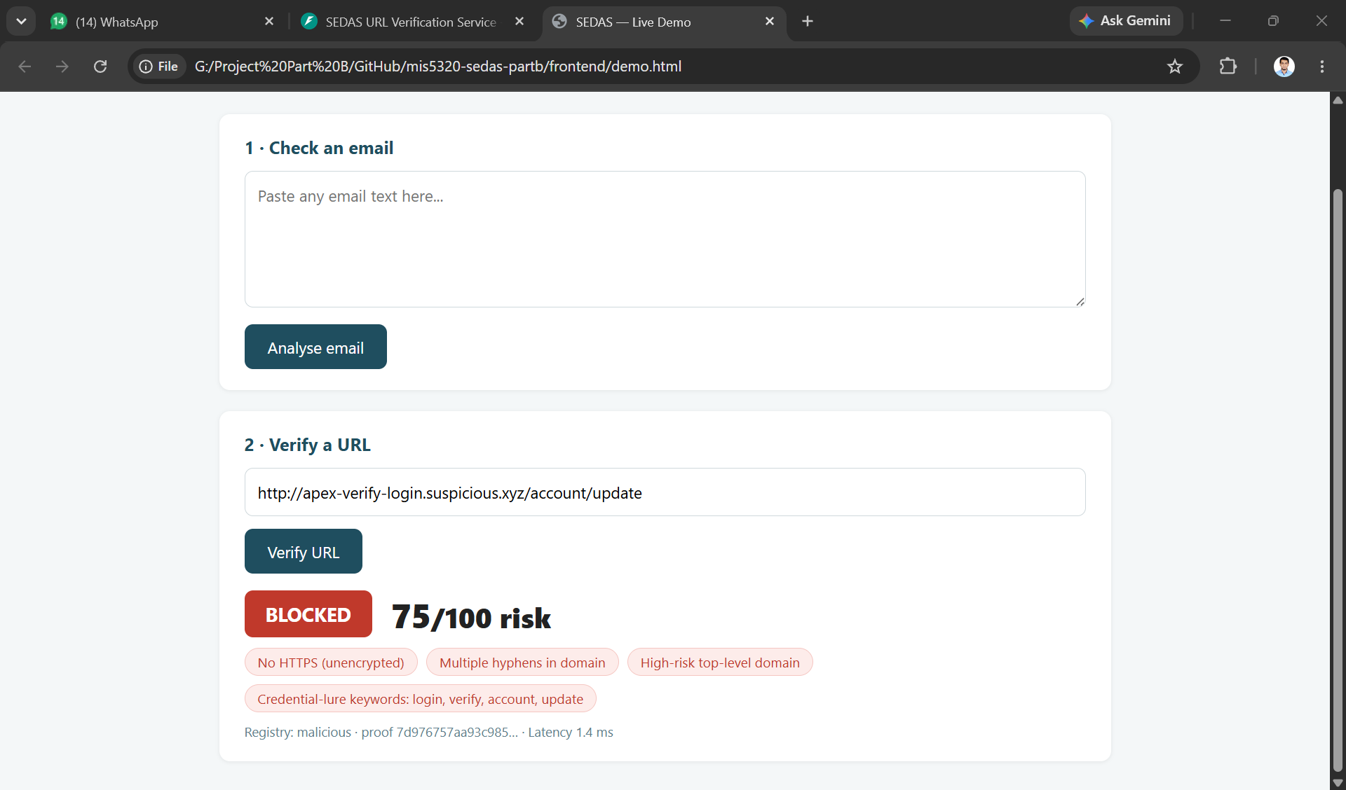
URL verification through the interface: previously reported URL returns BLOCKED at 75/100 with registry status 'malicious' and chain proof hash displayed, 1.4 ms (FR-03, FR-04).

3. Environment & Infrastructure Setup
- Platform. Windows 11 workstations; Python 3.14 in per-project virtual environments; Visual Studio Code; Git with GitHub Desktop.
- Stack. Detection — FastAPI + uvicorn, scikit-learn (TF-IDF, LogisticRegression, LinearSVC), pandas, joblib. URL verification — FastAPI, hashlib (SHA-256), sqlite3. Training — FastAPI, sqlite3. Frontend — HTML/CSS/vanilla JavaScript (React retained for the full dashboard). Testing — pytest with FastAPI TestClient.
- Service topology. Three independent services on ports 8001 (detection), 8002 (URL verification) and 8003 (training), each with its own datastore and health endpoint, preserving the Part A microservice decomposition.
- Repository hygiene. Datasets, trained model binaries, generated databases (registry.db, training.db) and virtual environments are excluded via .gitignore; configuration follows a committed .env.example pattern with no secrets in version control.
- Continuous integration. GitHub Actions runs the pytest suite on every push and pull request. Model-dependent tests skip cleanly where the locally trained model is absent; model-free tests (including the URL verification suite) execute in CI, so the pipeline now exercises real assertions.
- Branching. main is protected; team contributions are made on feature branches and merged through reviewed pull requests.

4. Testing Status
Test ID | Coverage | Traced to | Status
TD-01..TD-05 | Detection: health, phishing detection, legitimate pass-through, explainability, latency | FR-01, FR-02, FR-09, NFR-03 | Passing
TU-01..TU-03 | URL verification: heuristic flagging, report-then-blocked flip with proof, chain integrity | FR-03, FR-04 | Passing
TT-01..TT-05 | Training: score calculation, risk EWMA up/down, risk bands, persona-aware lesson selection | FR-05, FR-06 | Specified — with module owner
TS-01..TS-05 | Security and negative cases: SQL metacharacter handling, empty input, unknown user 404, quiz answer withholding, health checks | NFR-05 | Specified — with module owner
Current suite: 8 tests passing in 4.4 s locally and in CI. Model evaluation is reported separately against NFR-01 with full confusion matrices.

5. Progress Against KPIs
KPI (Part A §4.5) | Target | Result | Status
Detection F1 | ≥ 0.95 | 0.9916 (SVM) · 0.9865 (LR) | Met; matches benchmark [41]
False-positive rate | < 2% | 0.95% (SVM) · 1.44% (LR) | Met
Classification latency | < 2,000 ms (R-05) | ≈ 7–11 ms (CPU) | Met
URL verification latency | < 2,000 ms (R-05) | ≈ 1.4–9.3 ms | Met
Registry tamper-evidence | Verifiable chain | chain/validate = valid | Met (PoC scope, R-01)
Risky-click reduction (RBCR) | 30% (simulated) | Transition phase | Scheduled
Training uptake > 80% | Deferred | No real user population | Documented as future work

6. Issues, Risks & How You Handled Them
- Benchmark comparability (supervisor's primary concern). Risk that our results would not be comparable to published work. Resolved by tracing the dataset to its own source publication rather than selecting a topically similar paper — giving an identical-corpus comparison. Verified by matching class counts exactly (42,891 / 39,595).
- Replication variance. Our SVM replication returns 0.9916 against the published 0.99. Treated as a match rather than a discrepancy: the paper reports to two decimal places and does not fully specify preprocessing (feature count, n-gram range, stop words, split seed, class weighting). An exact four-decimal reproduction would be implausible; landing in the same performance band is what validates the pipeline.
- Work distribution. Supervisor identified concentration of work in one person as a serious risk. Addressed by formalising the RACI with a single accountable owner per activity, writing individual technical briefs with specifications rather than finished code for module owners, adopting branch-and-pull-request workflow, and issuing a viva preparation document so each member can defend their module independently.
- Cross-origin request failure. Browser requests from the local demo page were blocked by the same-origin policy. Resolved with CORS middleware on both services, deliberately permissive for local demonstration and immediately recorded as an OWASP A05 finding for restriction before deployment — an example of the security assessment process operating during development rather than after it.
- Malformed input during testing. Early API tests returned HTTP 422 due to malformed request bodies. Root cause identified from the validation error detail; corrected requests classified successfully. Retained as negative-test evidence that server-side input validation rejects malformed input with a descriptive error rather than failing (NFR-05).
- Data validity limitation. Model quality on public research corpora will not transfer unchanged to live institutional mail (domain shift). Recorded openly rather than presented as a deployment guarantee; the transformer comparison and, in production, retraining on institutional data are the mitigations.
- Repository hygiene. Generated artefacts (trained model, registry.db, training.db) initially appeared in version control. Added to .gitignore before commit; the repository holds code, documentation and evidence only, with the model reproducible via train.py.

7. Plan for Next Week (Week 4)
- Transformer comparison. Fine-tune a DistilBERT classifier on the same corpus and evaluate with the same metrics, completing a three-way comparison: published SVM benchmark [41], our classical baseline, and a transformer. This is the preliminary-results milestone.
- Training module completion. Module owner to implement the scoring engine (attempt scoring, EWMA risk update, banding, adaptive selection) and tests TT-01..TT-05, bringing the training service to a running state.
- Awareness content expansion. Extend the lesson and question library across the three personas and all difficulty levels so adaptive selection has sufficient content.
- Security assessment. OWASP Top 10 self-assessment against our own services with findings, severities and fixes documented; security and negative tests TS-01..TS-05 added.
- Governance dashboard. Charts for detection volume, risk distribution and training completion (FR-07), integrating all three services behind one interface.
- Presentation 1 preparation. Five-minute MVP presentation covering problem, approach, artefact demonstration with justification, testing status, and ethical/security/privacy considerations, with a recorded backup demonstration.

8. Attachments
- Meeting Minutes #1 — supervisor consultation (docs/minutes/)
- Meeting Minutes #2 — team meeting, module allocation (docs/minutes/)
- Dataset and Benchmark Justification (docs/)
- Implementation Project Plan with final RACI (docs/)
- Evidence screenshots (docs/evidence/)

9. Supervisor Notes (Optional)

